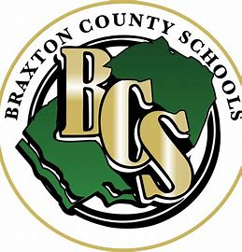

A Message from the AD:
The Braxton County Athletic Department would like to remind everyone, Let the players play, coaches coach, officials Officiate, and fans stay positive. Be loud, proud and respectful of everyone. Our events are all about the players and competition. Negative behavior will not be tolerated.

